Experiment 15 : DESIGN AND PERFORMANCE ANALYSIS OF PASSIVE OPTICAL NETWORK (PON) USING OPTISYSTEM
OBJECTIVES :
  - To design a wavelength-division multiplexed passive optical network (WDMPON) using OptiSystem.
  - To transmit multiple optical channels through a common single-mode fiber and passive optical splitter.
  - To evaluate the received signal quality using eye diagrams, Q-factor and biterror rate (BER).

SOFTWARE USED : Optisystem
CIRCUIT DIAGRAM:
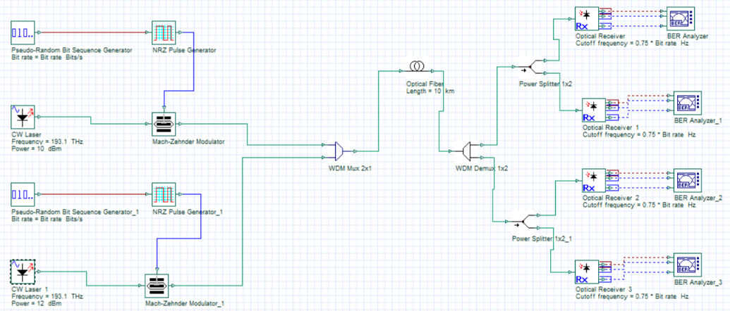
RESULTS:
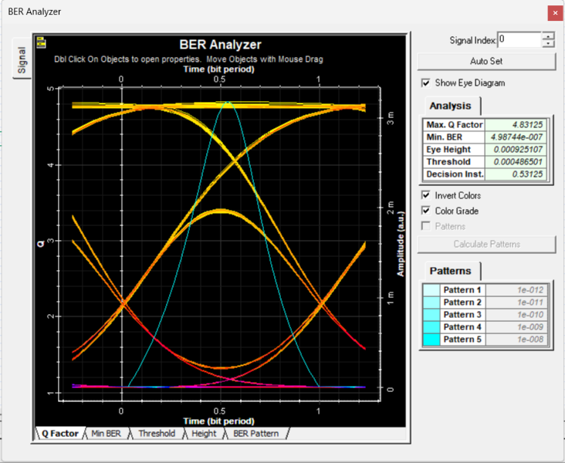 | 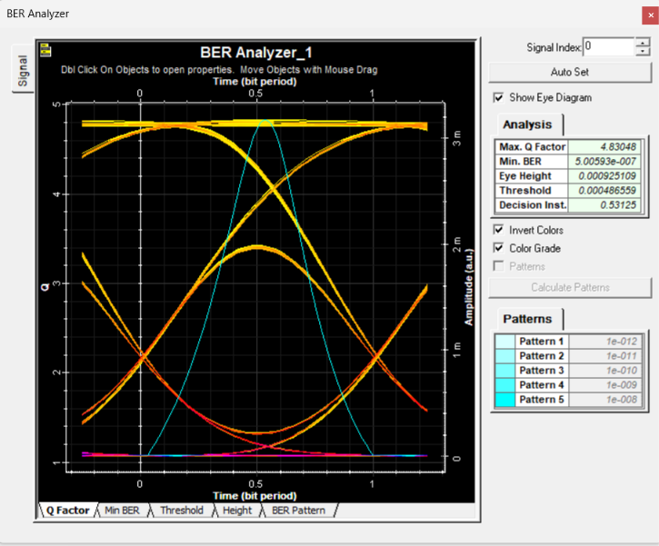
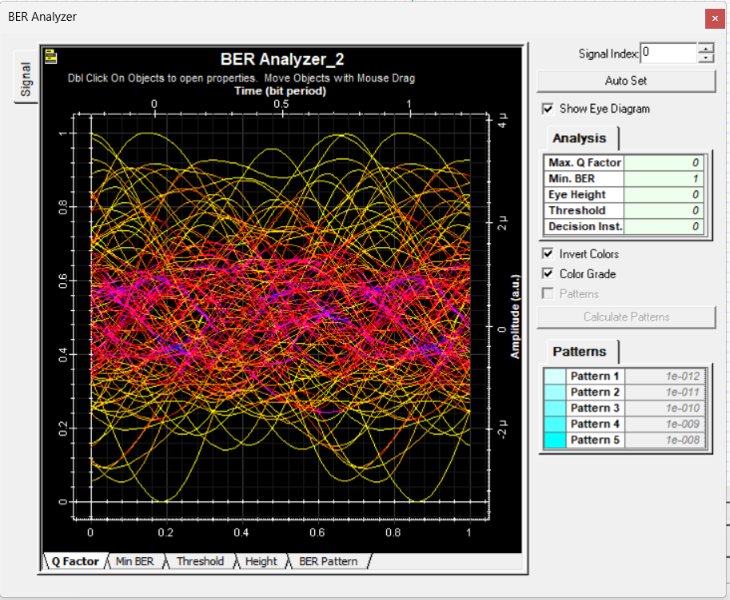 | 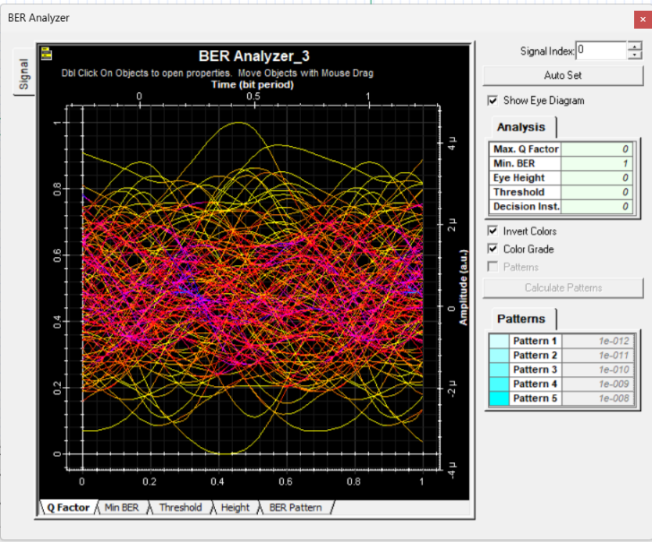

REFLECTION:
I learned to design and simulate a WDM-based passive optical network (PON) using Optisystem and transmit multiple wavelength channels through a shared optical fiber and passive splitter.
I evaluated the received signal quality using eye diagrams, Q-factor and BER understanding how optical losses affect network performance
RUBRICS:
Objective | Assessment Criterion | Excellent – 4 | Good – 3 | Satisfactory – 2 | Needs  Improvement –  1 | Weighta ge
System  Design &  WDM-PON  Setup | Correct selection and connection of  OptiSystem components for the  WDM-PON (PRBS  Generators, NRZ  Generators, CW  Lasers, 2×1 WDM  MUX, SMF, 1×2  Passive Splitter, PIN  Photodetectors with filters, BER  Analyzers). | All transmitters,  WDM multiplexer, fiber, splitter,  receivers, and  analyzers are  correctly selected, connected in  sequence, and  configured without errors. | All  components are present  with minor connection or layout  errors, but  the network remains functional. | Component selection is partially  complete; minor  connection or  configuratio n errors impede  signal flow  on one or more channels. | Incorrect component selection or  improper setup leading to complete  simulation failure. | 20%
Parameter  Configurati on &  Execution | Accurate setup of input parameters: bit  rate (2.5 Gb/s), NRZ-  OOK, laser wavelengths (1550.12 nm, 1550.92 nm),  power (10 dBm), SMF length (20 km),  attenuation (0.2  dB/km), dispersion  (16.75 ps/nm/km), and splitter loss (6.02 dB). | All block parameters are accurately set  and the simulation is executed for all channels. | Parameters are mostly accurate  with minor setting  discrepancie  s. | Basic parameters are  configured,  but multiple channel or  fiber settings are missing. | Incorrect parameter settings or  failure to run the  simulation for the required channels. | 20%
Measureme nt & Eye  Diagram  Observation | Accurate extraction and recording of Max.  Q-Factor, Min. BER,  Eye Height,  Threshold, and  Decision Instant from each BER Analyzer. | Precise data extraction for all BER  Analyzers, neatly tabulated, with clear eye diagrams  captured for each channel. | Data is collected  with minor  omissions in  Q-factor, BER, or eye parameters. | Partial data collection with  incomplete tables or  missing eye diagrams. | Inaccurate, incomplete, or  missing data and  measurements. | 20%
Channel  Performanc e & Link  Impairment Analysis | Detailed evaluation of per-channel  performance and the effects of fiber  attenuation,  chromatic dispersion,  and splitter loss on Qfactor, BER, and eye opening. | Comprehensive  analysis correctly  relating splitter loss, attenuation, and  dispersion to Q-  factor reduction, BER increase, and  channel-to-channel variation. | Clear analysis  identifying  basic trends  in Q-factor  and BER across channels. | Basic attempt at result  analysis without  explaining  mechanisms such as  splitter loss or  dispersion. | Erroneous or missing analysis of simulation  results and eye diagrams. | 20%
Report & Conclusion | Identification of best and worst performing  channels, assessment of whether BER  targets are met, and structural clarity. | Report features clear eye diagrams,  complete output  tables, and insightful conclusions  comparing channel  quality and network limits. | Satisfactory report with  relevant eye diagrams  and sound  concluding summary. | Incomplete report with missing  diagrams,  tables, or weak  conclusions. | Disorganized or incomplete  report lacking required  diagrams and valid  conclusions. | 20%

CONCLUSION:
A WDM-PON system was successfully designed and tested using OptiSystem. Multiple wavelengths were multiplexed, transmijed through fiber, split, and detected at the receivers. Q-factor, BER, and eye-diagram results confirmed channel performance and showed the effects of ajenuation, dispersion, and splijer loss, verifying the operation of the WDM-PON network.

